**Database specification**

1. **ERD**

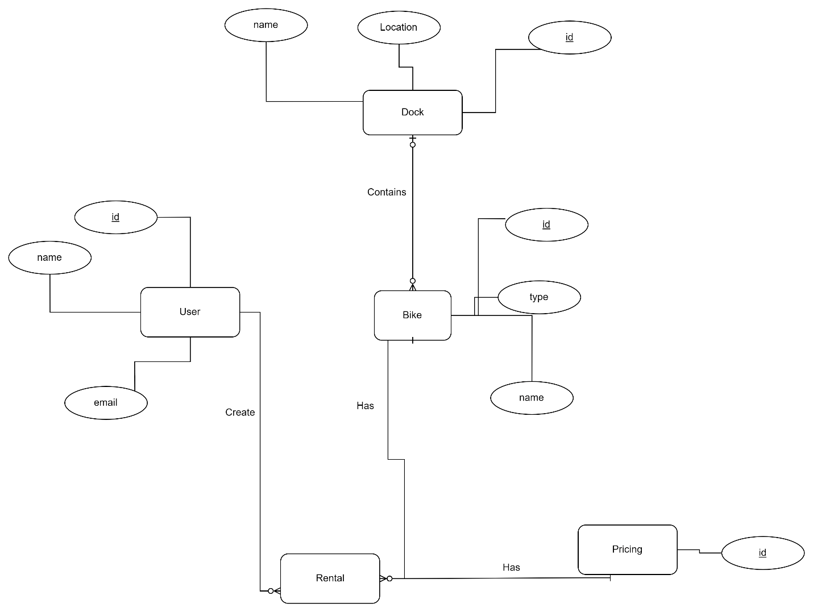

1. **Database Schema**

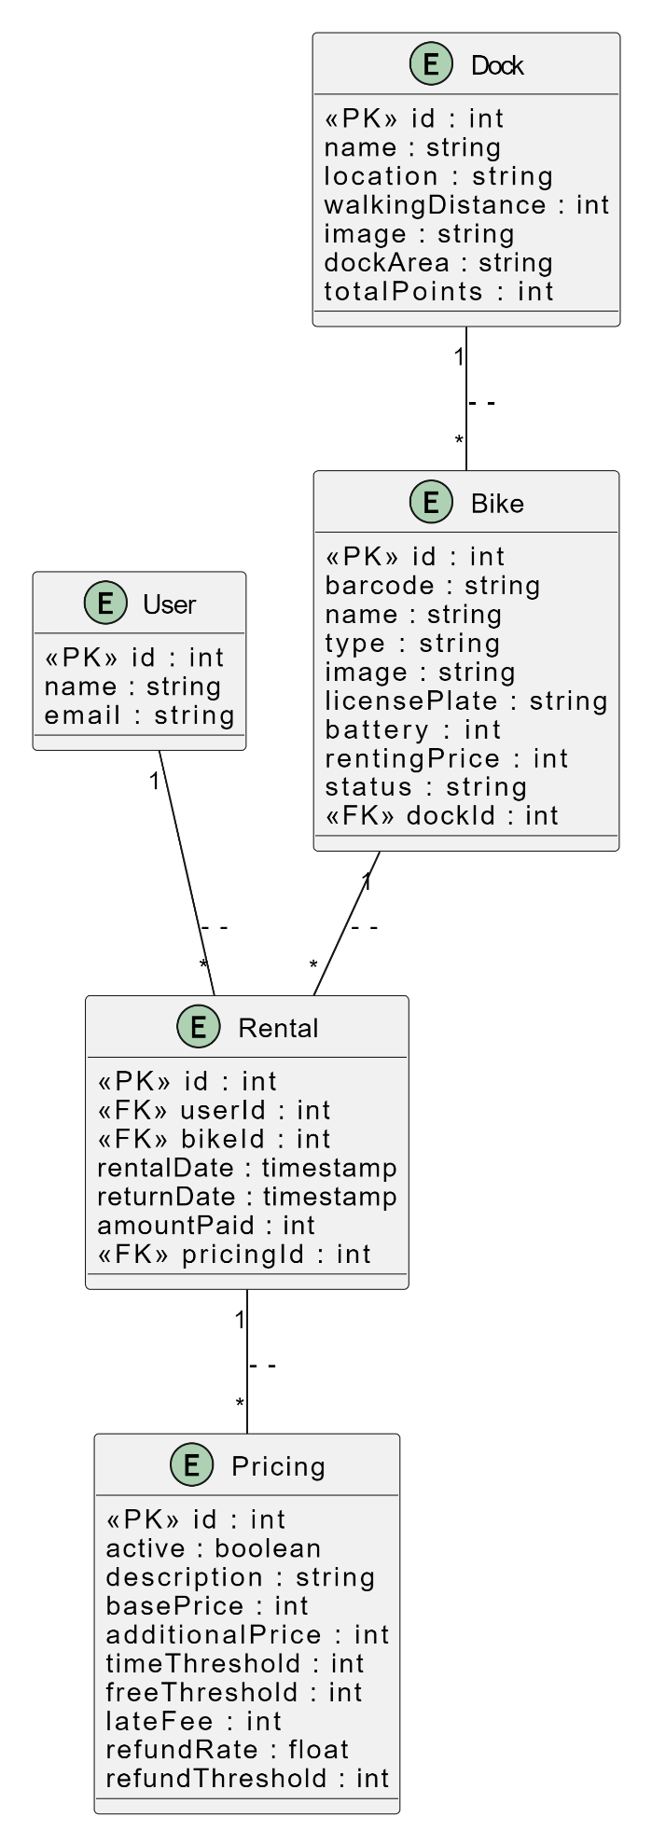

1. **Database Detailed Design**

* **Bike**

|  |  |  |  |  |  |  |
| --- | --- | --- | --- | --- | --- | --- |
| **No.** | **PK** | **FK** | **Name** | **Data type** | **Mandatory** | **Description** |
| 1 | Yes | No | id | INT | Yes | Primary key - Auto-generated unique identifier. |
| 2 | No | No | barcode | VARCHAR(255) | Yes | Unique barcode associated with the bike. |
| 3 | No | No | name | VARCHAR(255) | Yes | Name of the bike. |
| 4 | No | No | type | ENUM | No | Type of the bike (e.g., STANDARD, etc.). |
| 5 | No | No | image | VARCHAR(255) | No | URL or path to the image of the bike. |
| 6 | No | No | licensePlate | VARCHAR(255) | Yes | License plate number of the bike. |
| 7 | No | No | battery | NUMERIC | Yes | Battery level of the bike. |
| 8 | No | No | rentingPrice | NUMERIC | Yes | Renting price for the bike. |
| 9 | No | No | status | ENUM | No | Current status of the bike (e.g., FREE, etc.). |
| 10 | No | Yes | dockId | INT | No | Foreign key referencing the Dock table. |

* **Dock**

|  |  |  |  |  |  |  |
| --- | --- | --- | --- | --- | --- | --- |
| **No.** | **PK** | **FK** | **Name** | **Data type** | **Mandatory** | **Description** |
| **1** | **Yes** | **No** | **id** | **INT** | **Yes** | **Primary key - Auto-generated unique identifier.** |
| **2** | **No** | **No** | **name** | **VARCHAR(255)** | **No** | **Name of the dock.** |
| **3** | **No** | **No** | **location** | **VARCHAR(255)** | **No** | **Location of the dock.** |
| **4** | **No** | **No** | **walkingDistance** | **NUMERIC** | **No** | **Walking distance to the dock.** |
| **5** | **No** | **No** | **image** | **VARCHAR(255)** | **No** | **URL or path to the image of the dock.** |
| **6** | **No** | **No** | **dockArea** | **VARCHAR(255)** | **No** | **Area of the dock.** |
| **7** | **No** | **No** | **totalPoints** | **NUMERIC** | **No** | **Total points associated with the dock.** |

* **Pricing**

|  |  |  |  |  |  |  |
| --- | --- | --- | --- | --- | --- | --- |
| **No.** | **PK** | **FK** | **Name** | **Data type** | **Mandatory** | **Description** |
| **1** | **Yes** | **No** | **id** | **INT** | **Yes** | **Primary key - Auto-generated unique identifier.** |
| **2** | **No** | **No** | **active** | **BOOLEAN** | **No** | **Indicates if the pricing is currently active.** |
| **3** | **No** | **No** | **description** | **VARCHAR(255)** | **Yes** | **Description of the pricing.** |
| **4** | **No** | **No** | **basePrice** | **NUMERIC** | **Yes** | **Base price in VND.** |
| **5** | **No** | **No** | **additionalPrice** | **NUMERIC** | **Yes** | **Additional price in VND.** |
| **6** | **No** | **No** | **timeThreshold** | **NUMERIC** | **Yes** | **Time threshold in minutes for regular pricing.** |
| **7** | **No** | **No** | **freeThreshold** | **NUMERIC** | **No** | **Time threshold in minutes for free period.** |
| **8** | **No** | **No** | **lateFee** | **NUMERIC** | **Yes** | **Late fee in VND.** |
| **9** | **No** | **No** | **refundRate** | **NUMERIC** | **Yes** | **Refund rate as a decimal (e.g.15000VNĐ for each 15 min).** |
| **10** | **No** | **No** | **refundThreshold** | **NUMERIC** | **Yes** | **Refund threshold in hours.** |

* **Rental**

|  |  |  |  |  |  |  |
| --- | --- | --- | --- | --- | --- | --- |
| **No.** | **PK** | **FK** | **Name** | **Data type** | **Mandatory** | **Description** |
| **1** | **Yes** | **No** | **id** | **INT** | **Yes** | **Primary key - Auto-generated unique identifier.** |
| **2** | **No** | **Yes** | **userId** | **INT** | **Yes** | **Foreign key referencing the User table.** |
| **3** | **No** | **Yes** | **bikeId** | **INT** | **Yes** | **Foreign key referencing the Bike table.** |
| **4** | **No** | **No** | **rentalDate** | **TIMESTAMP** | **Yes** | **Timestamp when the rental started.** |
| **5** | **No** | **No** | **returnDate** | **TIMESTAMP** | **No** | **Timestamp when the rental was returned.** |
| **6** | **No** | **No** | **amountPaid** | **NUMERIC** | **Yes** | **Amount paid for the rental in VND.** |
| **7** | **No** | **Yes** | **pricingId** | **INT** | **Yes** | **Foreign key referencing the Pricing table.** |